ELIGIBILITY CERTIFICATION

The undersigned certifies, to the best of their knowledge and belief, that:

- The organization is unable to finance the proposed project from its own resources or through commercial credit at reasonable rates and terms.

- No outstanding judgment has been obtained and recorded by the United States of America in a Federal Court (other than in the United States Tax Court).

- I certify that no one in our organization has no known relatives or close associates that are currently USDA Rural Development employees.

- I certify that this project is consistent with local development plans.

- I certify that the attached list of board/council members with their terms is current as of this date.

- I certify that any cost overruns will be the responsibility of the applicant.

- I certify that we have procurement regulations that comply with State and local laws, rules, and regulations.

- I certify that we will comply with all provisions of 3570-B instructions and 1942-A as applicable.

Pacific Horizons School, Inc.
Name of Organization

Genhall Manua Chen
Name of Authorized Official

Date: _______03/18/2021________

Attachment: *Current list of board/council members with terms

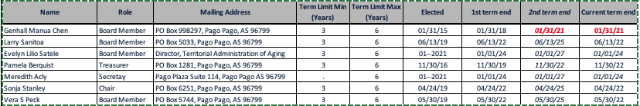

Revised 05/11/16

